**UNIT 5**

One of the reasons for separating business operations into functional areas is to allow each to operate within its area of expertise, thus building efficiency and effectiveness across the business as a whole. Functional areas in a business vary according to the nature of the market and the size of the business. For example, manufacturing companies like Nike and Apple have significant Research and Development (R&D) departments in order to stay in the lead in their respective business segments. On the other hand, retail companies may have no R&D functional area per se, but will be heavily invested in Operations areas surrounding Supply Chain Management.

In general, the key functional areas of a business are the following:

* Hr Management/Department
* Operations /Production Department
* Marketing/Sales
* Finance Department
* Research and Development

Each of these functional areas are represented in the following organization chart.

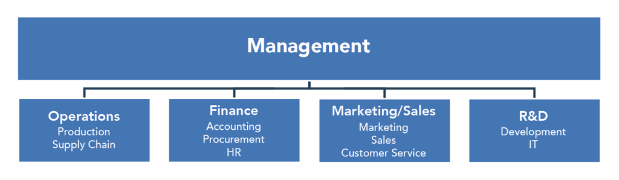

**Management**

The primary role of managers in business is to supervise other people’s performance. Most management activities fall into the following categories:

* **Planning**: Managers plan by setting long-term goals for the business, as well short-term strategies needed to execute against those goals.
* **Organizing:** Managers are responsible for organizing the operations of a business in the most efficient way, enabling the business to use its resources effectively.
* **Controlling:** A large percentage of a manager’s time is spent controlling the activities within the business to ensure that it’s on track to achieve its goals. When people or processes stray from the path, managers are often the first ones to notice and take corrective action.
* **Leading**: Managers serve as leaders for the organization, in practical as well as symbolic ways. The manager may lead work teams or groups through a new process or the development of a new product. The manager may also be seen as the leader of the organization when it interacts with the community, customers, and suppliers.

**Operations**

Operations is where inputs, or factors of production, are converted to outputs, which are goods and services. **Operations is the heart of a business providing goods and services in a quantity and of a quality that meets the needs of the customers.** Operations control the supply chain, including procurement and logistics.

**Marketing/Sales**

**Marketing** consists of all that a company does to identify customers’ needs and design products and services that meet those needs. The marketing function also includes promoting goods and services, determining how the goods and services will be delivered, and developing a pricing strategy to capture market share while remaining competitive. In today’s technology-driven business environment, marketing is also responsible for building and overseeing a company’s Internet presence (e.g., the company website, blogs, social media campaigns, etc. Today, social media marketing is one of the fastest growing sectors within the marketing function.

The goal of **Sales** is to close the revenue the company needs in order to operate profitably, especially in B2B businesses. Again, depending on the nature of the market and the company size, Sales functional areas can vary in structure and approach: inside/outside representation, vertical/horizontal focus, direct, etc. Sales works to exploit the leads created by Marketing and activities generated by the sales force itself.

**Finance**

The **Finance** function involves planning for, obtaining, and managing a company’s funds. Finance managers plan for both short-term and long-term financial capital needs and analyze the impact that borrowing will have on the financial well-being of the business. A company’s finance department answers questions about how funds should be raised (loans vs. stocks), the long-term cost of borrowing funds, and the implications of financing decisions for the long-term health of the business.

Accounting is a crucial part of the Finance functional area. Accountants provide managers with information needed to make decisions about the allocation of company resources. This area is ultimately responsible for accurately representing the financial transactions of a business to internal and external parties, government agencies, and owners/investors. Financial Accountants are primarily responsible for the preparation of financial statements to help entities both inside and outside the organization assess the financial strength of the company. Managerial accountants provide information regarding costs, budgets, asset allocation, and performance appraisal for internal use by management for the purpose of decision-making.

**Key People Within Functional Areas**

Here is an example of the functional areas of a large technology manufacturing corporation and the key functions and people within.

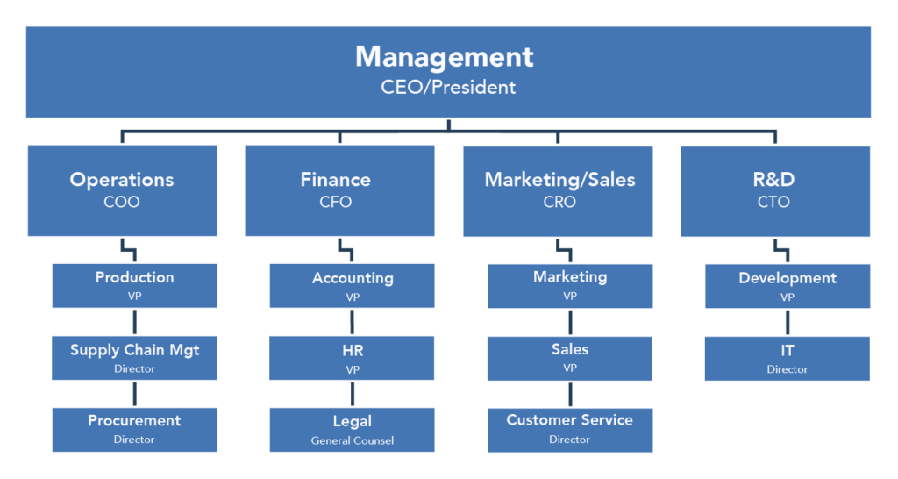

The **Management** functional area in most large corporations is led by the Chief Executive Officer (CEO). Depending on company size, there may be a President in position as well.

The **Operations** functional area is managed by the Chief Operations Officer (COO). In this example, Operations consists of Production, led by a Vice President (VP), a Supply Chain department, and a Procurement area with Director-level people in charge.

The **Finance** functional area is led by the Chief Financial Officer (CFO), who is one of the most important “C-level” executives. In addition to running Finance and Accounting, the CFO is responsible for reporting company results to the financial community. Finance also contains Human Resources (HR) in many companies and the Legal department as well. It is common for the CFO to have VPs of HR, Accounting, and Legal as direct reports. HR contains functions like employee training, compensation and benefits, and recruiting. Accounting has multiple functions such as Accounts Payable, Receivable, record-keeping and cash flow. The Legal department is responsible for contracts, copyrights, and various negotiations on behalf of the company.

The **Marketing/Sales** functional area is managed by the Chief Revenue Officer (CRO), which is a relatively new addition to C-level executives. The CRO may have a Sales VP and Marketing VP as direct reports, but in some cases the CRO may act as VP of Sales or Marketing. This functional area may also contain Customer Service (and Support) with a Director-level manager in charge. Marketing has specialized functions such as communications (press releases), social media, data science analysis and product marketing. Customer Service is usually responsible for Customer Relationship Management (CRM) and problem resolution and support.

Finally, the **Research and Development** functional area is the lifeblood of manufacturing businesses. R&D is staffed with scientists, thought-leaders, subject-matter experts and industry analysts striving to provide the organization with knowledge and ideas to keep up and ahead of the competition. R&D is led by the Chief Technology Officer (CTO), who manages a Development VP or similar title depending on what technology products are being produced: semiconductors, athletic footwear, software systems, or dental appliances. In many organizations, the Information Technology area (IT), responsible for providing internal technology tools to the company’s employees, is housed in the R&D organization.

# 6 Most Important Functions of Business

The various functions of business can be grouped into the following broad categories:

1. Production Function;

2. Marketing Function;

3. Finance Function;

4. Human Resource Function;

5. Management Information /IT Function;

6. Innovation (Research & Development).

### ****1. Production function:****

Production is the creation of goods and services with the help of certain processes. The production of goods depends essentially on the organisation of men, money, materials, and facilities into a smoothly operating business. In modern organisations, production is highly organised, mechanized, and specialised mass production, and, therefore, its overall charge is entrusted to the Production Manager.

A production manager has four basic responsibilities in this regard : (i) to ensure the production of goods and services in specified quantities, (ii) to meet the specified time schedule or delivery dates, (iii) to fulfill the quantity requirements, and (iv) to perform all production operations at the minimum cost.

In order to fulfill these responsibilities, the production manager has to perform a number of functions, such as production planning, production engineering (concerned with design of tools, jigs, and installation or equipment), plant layout, plant building, materials handling, purchasing, inventory management, work improvement and work measurement, production control, and the maintenance of physical environment of production.

### ****2. Marketing function:****

Marketing is the process of getting goods and services into the hands of the consumer with a view to satisfying the needs and desires of consumers and producers. In other words, the marketing function creates a process through which producers and consumers are brought together in an exchange relationship and transfer of ownership takes place.

For this, the marketing manager must make judicious decisions regarding 4 P’s: (i) product (decisions about new product development, packaging, branding, etc.); (ii) physical distribution (decisions about marketing channels, and policies and procedures relating to warehousing, transportation, etc.); (iii) promotion (involving advertising, salesmanship, sales promotion, and publicity); and (iv) pricing (policies and procedures relating to the setting up of profitable prices).

### ****3. Finance function:****

Finance function of business is basically responsible for three decisions and their proper implementation, viz., (i) investment decisions (financial planning, capital budgeting, etc.) (ii) Financial decisions (capital structure—fixed and working; short and long-term and (iii) dividend decisions.

Business maintains relationship with financial markets including institutions and major shareholders and also takes care of other concerns such as share buybacks, capital raising sources of borrowings and risk management.

### ****4. Human Resource (HR) function:****

The HR function deals with the human side of business. It is concerned with increasing the effectiveness of human performance in any organisation. Specifically stated, the HR function aims at obtaining arid maintaining a capable and effective workforce, motivating the employees individually and in groups to contribute their maximum to the fulfilment of organisational goals.

In order to accomplish the goals of dynamic HR management, the HR manager has to undertake the following functions : (i) selection—determination of manpower requirements, job analysis, nature and sources of recruitment, employee selection, and induction and follow-up; (ii) training—human resource development; (iii) promotions and transfers, (iv) employee compensation—wage and salary administration; (v) employee involvement and welfare activities; and (vi) industrial relations—industrial discipline, industrial unrest, trade unionism, and workers’ participation in management. For the accomplishment of these functions, the personnel department renders specialised services.

### ****5. Information function:****

Like production, marketing, finance, and human resource, the information function is equally important in a modern business. It is being increasingly recognised that the modern business cannot be managed without the assistance of efficient information function. The information function is basically concerned with records.

The net result of the preparation of records is the generation of a mass of “information”, and therefore, the purpose of information function is to collect, generate, and communicate, in clearly and easily intelligible form the information to all those who need it, especially to executives for purposes of decision making and policy formulation.

Thus, information cell acts as a storehouse of valuable information and real brain behind every activity of a business concern. The responsibility of performing this function should be entrusted to the information manager in the organisation because information function is a specialist function requiring an expert knowledge and technical skill in this area of the operation. The scope of information function in a modern business is very wide.

The information manager is generally burdened with the following three broad functions: (i) information function (receiving and collecting, recording and preserving, arranging and analysing, and providing information); (ii) operational function (such as systems and procedures, records management, etc.); and (iii) public relations function.

### ****6. Innovation:****

“An innovation is the implementation of a new or significantly improved product (good or service), or process, a new marketing method, or a new organisation method in business practice, workplace organisation or external relations.” Thus, innovation, which means creativity as well, is more of a philosophy and the entire business function needs to adopt it.

Here in terms of new product development we are talking about Research and Development. In this age of increasing rivalry among competing firms, the importance of innovation is hardly exaggerating. Normally businesses innovate through product or process.

Innovation often is stimulated by creative thinking on the part of people who are willing to think ‘outside the box’.

The above description clearly explains that these functions of business are (1) basic in nature, and (2) mutually dependent. Each has a separate objective and should be so organised and performed that it contributes to the realisation of the objectives of the other. This will ultimately help realise the overall objectives of the business. This process of one function realising its own objectives and also contributing to other’ objectives is known as the ‘End-means Chain’.